Use Case Diagram

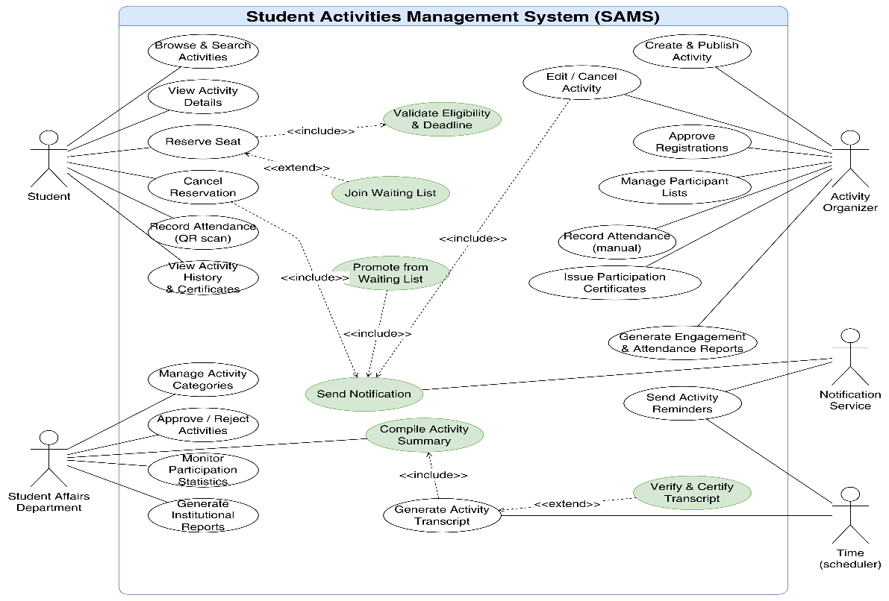
Figure 10 Use Case Diagram Student Activities Management System (SAMS)
Key relationships:
- Reserve Seat «includes» Validate Eligibility & Deadline since validation is mandatory for every booking process.
- Join Waiting List «extends» Reserve Seat: taking place conditionally only when an activity reaches full capacity.
- Cancel Reservation «includes» Send Notification ensuring that a notification is consistently dispatched following a cancellation.
- Edit / Cancel Activity «includes» Send Notification to inform enrolled participants about any updates or cancellations.
- Promote from Waiting List «includes» Send Notification to instantly notify a student once a slot opens up and they are promoted.
- Generate Activity Transcript «includes» Compile Activity Summary to collate participation records prior to formulating the complete document.
- Verify & Certify Transcript «extends» Generate Activity Transcript as official verification and validation are executed optionally upon request by Student Affairs.

